CI/CD Pipeline for Flask App using Terraform, Ansible & GitHub Actions in AWS
This document provides the complete setup and deployment flow for automating a Flask application deployment using Terraform, GitHub Actions, and Ansible.
Architecture Diagram
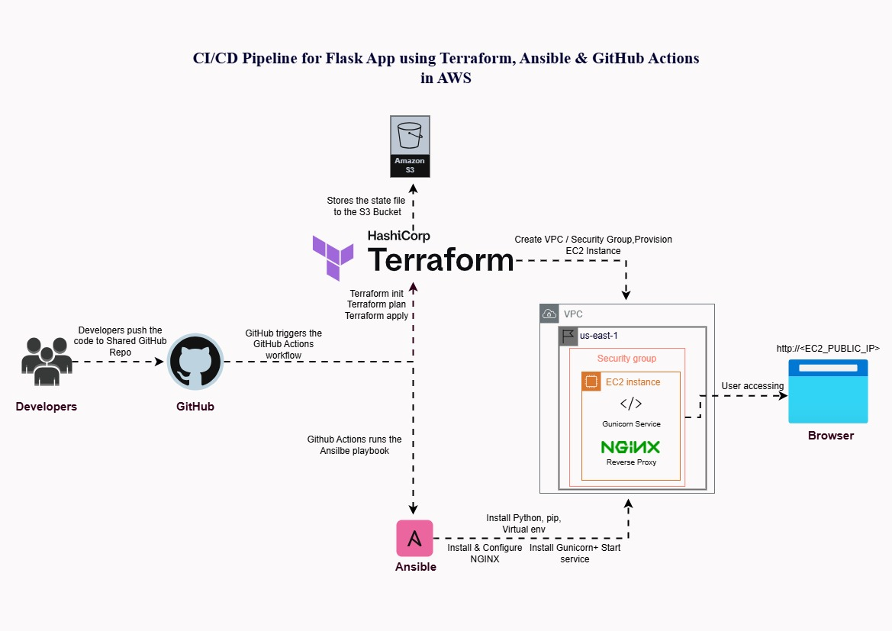
The architecture follows a standard GitOps approach where code changes trigger an automated workflow:
- Developer pushes code to GitHub.
- GitHub Actions initiates the pipeline.
- Terraform provisions the necessary AWS infrastructure (EC2, Security Group).
- Ansible connects to the new EC2 instance and deploys the Flask application, setting up Gunicorn and NGINX.
- The application becomes accessible via the EC2 Public IP.

Setup Instructions
1. Prerequisites
Local / Repository Requirements
Your GitHub repository must contain the following structure:
- terraform/ → All Terraform configuration files.
- ansible/deploy.yml → The main Ansible playbook for deployment.
- app/ → The Flask application source code.
- .github/workflows/ci-cd.yml → The GitHub Actions workflow definition.
AWS Requirements
- AWS Account.
- IAM User with the following minimum required permissions (for the pipeline):
  - AmazonEC2FullAccess
  - AmazonS3FullAccess
  - IAMReadOnlyAccess
  - AmazonVPCReadOnlyAccess
Note: This IAM user's credentials will be stored in GitHub Secrets.
- EC2 Key Pair (Must be created manually):
  - Go to AWS Console → EC2 → Key Pairs.
  - Create a key pair (e.g., avinash-key).
  - Download the .pem file.
  - Copy its contents and store it in GitHub Secrets as SSH_PRIVATE_KEY.
This key is crucial as it allows:
  - Terraform to associate the EC2 instance with the key pair.
  - GitHub Actions (via Ansible) to SSH into the EC2 instance for deployment.
GitHub Secrets Configuration
Go to: GitHub Repo → Settings → Secrets → Actions
Secret Name | Description
AWS_ACCESS_KEY_ID | IAM user access key
AWS_SECRET_ACCESS_KEY | IAM user secret key
SSH_PRIVATE_KEY | Content of the manually created .pem key pair

2. Project Repository Structure
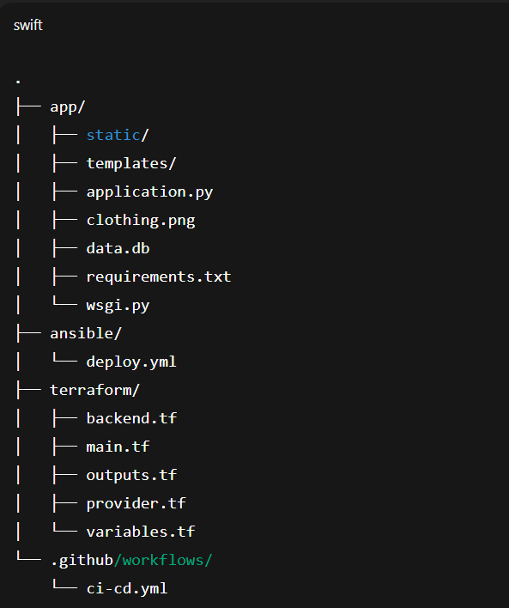

3. Configure Terraform Variables
In terraform/variables.tf, configure project-specific defaults:
variable "project_name" {
default = "flask-ecommerce"
}
variable "key_name" {
default = "ci-cd"
}

4. SSH Private Key Handling
The SSH_PRIVATE_KEY secret is used by the pipeline to enable Ansible's connection to the EC2 instance. The workflow performs these critical steps:
Bash
echo "${{ secrets.SSH_PRIVATE_KEY }}" > ssh_key.pem
chmod 600 ssh_key.pem
This creates a file named ssh_key.pem with restricted permissions (chmod 600) within the runner, which Ansible then uses for its SSH connection.

CI/CD Pipeline Deployment Workflow Breakdown
The deployment process is automatically initiated when code is pushed to the main branch of the GitHub repository.
Phase 1: Infrastructure Provisioning (Terraform)
This phase focuses on setting up the necessary cloud resources on AWS using GitHub Actions and Terraform.
- Checkout Repository Code: The GitHub Actions runner pulls the latest code files from the repository.
- Install Terraform & Ansible: The runner installs the required tools for the deployment workflow.
- Configure AWS Credentials: AWS authentication is established using the AWS_ACCESS_KEY_ID and AWS_SECRET_ACCESS_KEY stored securely in GitHub Secrets.
- Auto-Create S3 Backend Bucket (Crucial Fix): An Amazon S3 bucket is created to store the Terraform state file. This step is performed before terraform init to ensure state management is configured correctly.
- Terraform Init / Plan / Apply:
  - Terraform executes, provisioning the required infrastructure in AWS, including:
    - An EC2 instance (virtual server).
    - A Security Group to manage traffic (e.g., allowing ports 22 and 80).
    - Uses the AWS default VPC and subnets.
  - Output Public IP: Terraform outputs the newly provisioned EC2 Public IP address, which is crucial for the subsequent Ansible connection.
Phase 2: Deployment and Configuration (Ansible)
This phase ensures the newly created EC2 instance is ready to receive the application code and necessary services.
- Check SSH Availability: The pipeline adds a wait/retry loop to confirm the EC2 instance has fully booted and the SSH service is ready and reachable before proceeding with deployment tasks.
- Write ssh_key.pem: The content of the SSH_PRIVATE_KEY secret is written to a local file (ssh_key.pem) on the runner with restricted permissions (chmod 600). This file is used by Ansible to securely connect to the EC2 instance.
- Dynamic Inventory Creation: A temporary Ansible inventory file (inventory.ini) is generated dynamically, using the EC2 Public IP obtained from the Terraform output:
<EC2_IP> ansible_user=ubuntu ansible_ssh_private_key_file=ssh_key.pem
- Run Ansible Deployment: The final deployment command is executed, pointing Ansible to the generated inventory and the deployment playbook:

ansible-playbook -i inventory.ini ansible/deploy.yml
Phase 3: Ansible Deployment Tasks
The ansible/deploy.yml playbook performs the following setup tasks on the remote EC2 instance:
- Install System Dependencies:
  - Installs essential packages like Python3, Pip, Virtualenv, and the NGINX web server.
- Setup Flask Application:
  - Creates the target directory: /var/www/flaskapp.
  - Copies the application files (app/ directory) to the server.
  - Installs required Python packages using pip from the requirements.txt file.
- Configure Gunicorn:
  - Creates a systemd service unit for Gunicorn (a Python WSGI HTTP server).
  - Enables and starts the Gunicorn service, which runs the Flask application.
- Configure NGINX Reverse Proxy:
  - Creates an NGINX site configuration file.
  - This configuration sets up a reverse proxy, directing incoming traffic on port 80 to the running Gunicorn socket.
  - Enables the site configuration and restarts the NGINX service to apply changes.

Rollback / Destroy Infrastructure
To completely dismantle and remove all resources provisioned by Terraform (EC2 instance, Security Group, etc.), run the following commands from your local machine:
- Navigate into the Terraform configuration directory:
cd terraform
- Execute the destroy command. This command prompts you to confirm the deletion of all managed resources:
terraform destroy
Challenges & Learnings
The following challenges were encountered and resolved during the CI/CD pipeline development, leading to a more robust workflow:
- Terraform Could Not Create S3 Backend
  - Challenge: Terraform's init command requires the S3 bucket for remote state to already exist. It cannot create its own state bucket during initialization.
  - Solution: The S3 state bucket is created explicitly as an initial step within the GitHub Actions workflow before running terraform init.
- EC2 IP Extraction Failed in Pipeline
  - Challenge: Initial attempts to extract the newly created EC2 Public IP from the raw Terraform output using tools like grep or regular expressions often resulted in parsing errors.
  - Solution: The Terraform configuration was modified to include a clean, dedicated output variable for the EC2 IP. This allowed the pipeline to easily and reliably read the IP address, eliminating complex parsing logic.
- SSH Host Key Verification Errors
  - Challenge: The GitHub Actions runner was unable to establish an SSH connection with the new EC2 instance due to host key validation failures (a security measure intended for stable environments).
  - Solution: The Ansible connection was configured to disable StrictHostKeyChecking (e.g., in the Ansible settings or the SSH command) for the duration of the deployment.
- SSH Not Ready After EC2 Creation
  - Challenge: Even after Terraform reported the EC2 instance as created, the instance required extra time to boot and fully enable the SSH service. Ansible connections would frequently fail immediately after the terraform apply.
  - Solution: A wait/retry loop (e.g., using a bash script or an equivalent GitHub Actions step) was implemented. This loop continuously attempts the SSH connection until it succeeds, ensuring a stable connection before Ansible runs the deployment playbook.

